

# VIETNAMTOURIST

**Supervisor:** *NGUYỄN HẠ VY*

**Semester:** *01*

**Batch No:** *T1.2208.A2*

**Group No: *05***

|  |  |  |
| --- | --- | --- |
| **Order:** | **Full name** | **Roll No.** |
| *1.* | *NGUYỄN ANH KHOA* | Student1409163 |
| *2.* | *NGUYỄN XUÂN HƯNG* | Student1409144 |
| *3.* | *CAO MINH NHỰT* | Student1408002 |
| *4.* | *NGUYỄN HOÀNG MINH* | Student1409160 |

***Month****: 12* ***Year****: 2022*



This is to certify that

**Mr. NGUYỄN ANH KHOAC Mr. NGUYỄN XUÂN HƯNG Mr. CAO MINH NHỰT**

**Mr. NGUYỄN HOÀNG MINH**

Have successfully Designed & Developed

# VIETNAM TOURIST

Submitted by:

**Ms. NGUYEN HA VY**

Date Of Issue:

Authorized Signature:

# Content

Content Acknowledge Synopsis

Review 1

Review 2

Review 3 ..

Tasksheet ..

# Acknowledge

As we understand that the eProject is a step-by-step learning environment that closely simulates the classroom and Lab-based learning environment into actual implementation. It is a project implementation at your fingertips!! An electronic, live juncture on the machine that allows you to.

* Practice step by step i.e. laddered approach.
* Build a larger more robust application.
* Usage of certain utilities in applications designed by user.
* Single program to unified code leading to a complete application.
* Learn implementation of concepts in a phased manner.
* Enhance skills and add value.
* Work on real-life projects.
* Give a real-life scenario and help to create applications that are more complicated and useful.
* Mentoring through email support.

First of all, I would like to thank India Aptech for allowing my team to work on this fantastic eProject. We had a great experience with eProject this time.

Next, We would like to express my special thanks to our mentor, Ms. Ha Vy for the time and effort that she provided throughout the project. Your helpful advice and suggestions were beneficial to us during the completion of the project. In this respect, We are forever grateful to you.

Besides several mistakes we made in the project, we hope to have more opportunities to widen our knowledge in the web-developing world.

We will try to continue to learn and improve ourselves even more in the future.

Yours Sincerely, Team Group 05.

# Synopsis

The Objective of this program we aim is to give a sample project to work on real- life projects. These applications help us build a larger more robust application.

The objective is not to teach us HTML/JavaScript but to provide us with a real-life scenario and help us create basic applications using the tools.

Hence, we can revise the chapters before we start with the project.

This project is meant for students like us who have completed the module of HTML5. These programs should be done in the Lab sessions with the assistance of the faculty if required.

The website (in this project) is a tool that brings everything in the world to you such as historic monuments information natural knowledge and skill in technology...

It is very essential for us that will have a clear understanding of the subject. We think we should go through the project and solve the assignments as per the requirements given.

And get back [***eprojects@aptech.ac.in***](mailto:eprojects@aptech.ac.in) as the assigned schedule.

## Problem Definition

**Pleasant Tours** is into selling various tour products. They have predefined tours with

itineraries. The company advertises by distributing the pamphlets, advertising on

television and so on. Due to rapid development in internet field, the company

decides to launch a website where people will get all the information about the

various tour products available with them easily.

The website is to be developed for the Windows Platform using HTML5, JavaScript

and Geolocation. The site should work well in all leading browsers including Chrome,

IE, Firefox etc.

**Requirement Specification:**

The Web site is to be created based on the following requirements.

1) The Home Page should be created making use of Frames with a suitable logo

2) The site should display a menu which will contain the options for brief

introduction about the various products available, location of the shop and

any other information if required.

3) The information should be categorized according to different type of products

like if a User wants to see only ‘Beach Tours’ then he click on a

Link/button/menu etc and he will see different type of Beach Tours. Similarly

for ‘Hill Stations’, ‘Forts/Palaces’ and other products

4) When a user selects any product type, a list of products for that product type

will be displayed.

5) Itinerary of individual tour products should be displayed on the Web Page

along with the title but detailed itinerary should be stored in Individual Word

documents which can be downloaded or viewed by the User who wishes to

see the same.

6) Price List for all tours should be available for download.

7) There should be a “Contact Us” page which will have the Address of the

Company which is as follows and the mail address which when clicked will

invoke the local mail client from where they can send an email. Address of the

Company should be displayed using GeoLocation API (eg. GoogleMaps).

### Hardware/ software requirement:

#### Software:

* + Notepad/HTML editor
  + Dreamweaver

#### IE 5.0/ Netscape 6.0

#### Hardware:

* + A minimum computer system that will help you access all the tools in the courses is a Pentium 166 or better.
  + 64 Megabytes of RAM or better.

Home

Home

central travel

Northern travel

Southern travel

contact us

about us

product tags

product tags

product tags

product details

product details

product details

# 1.Homepage

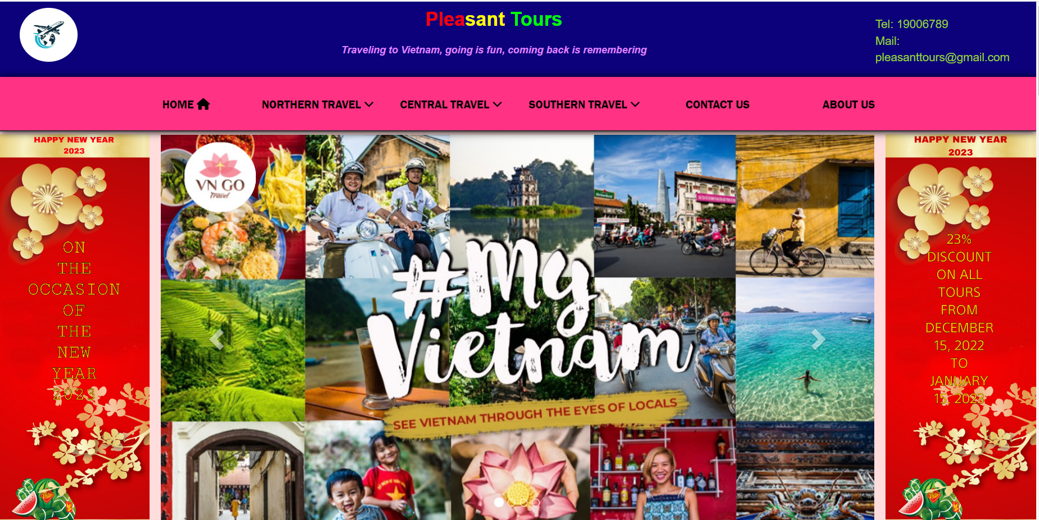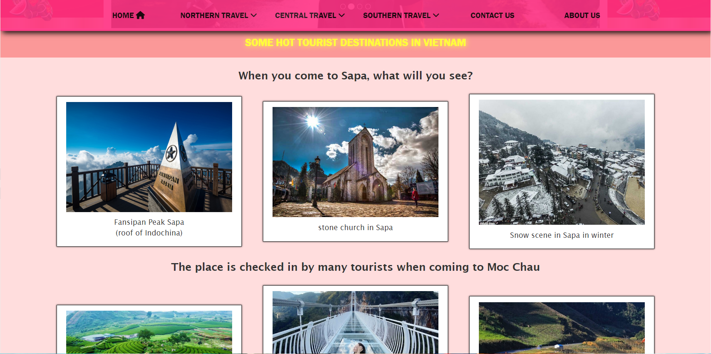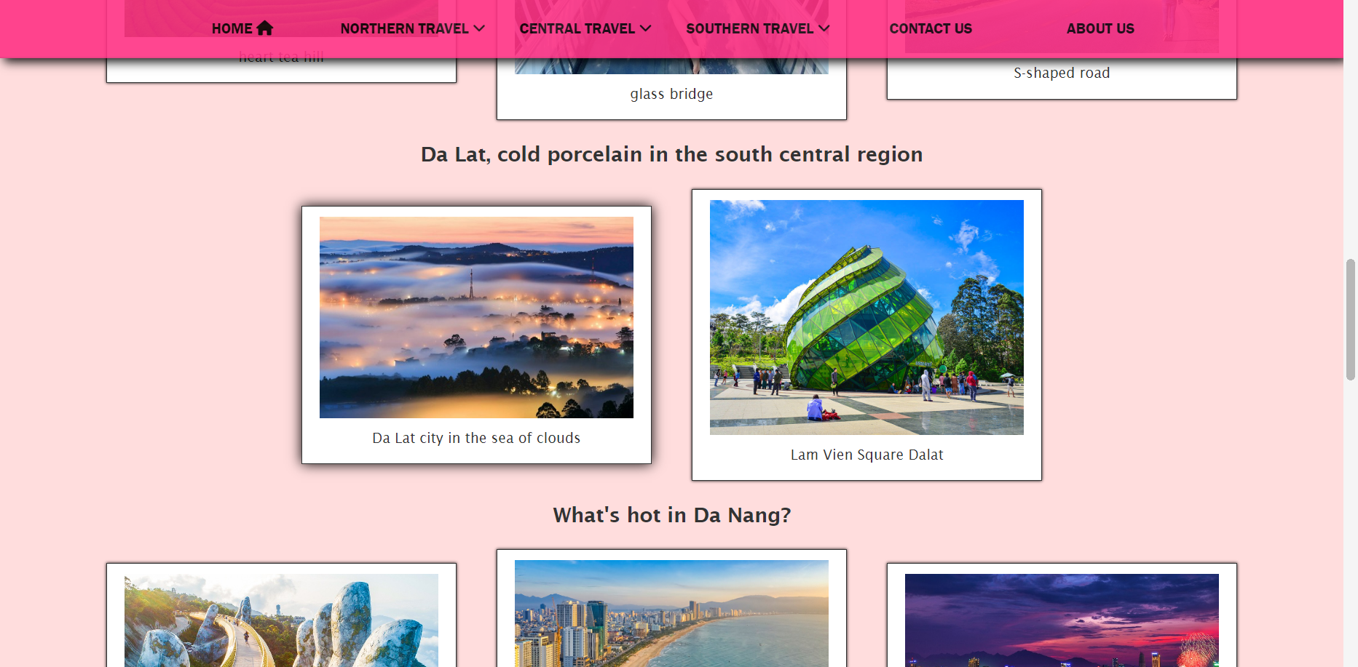

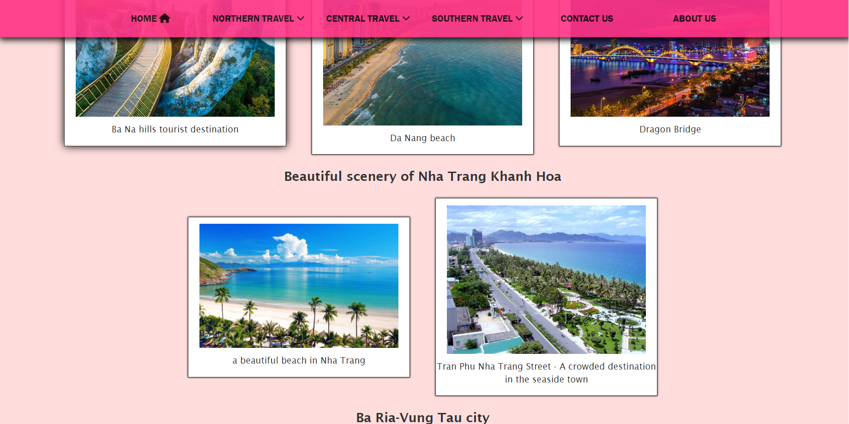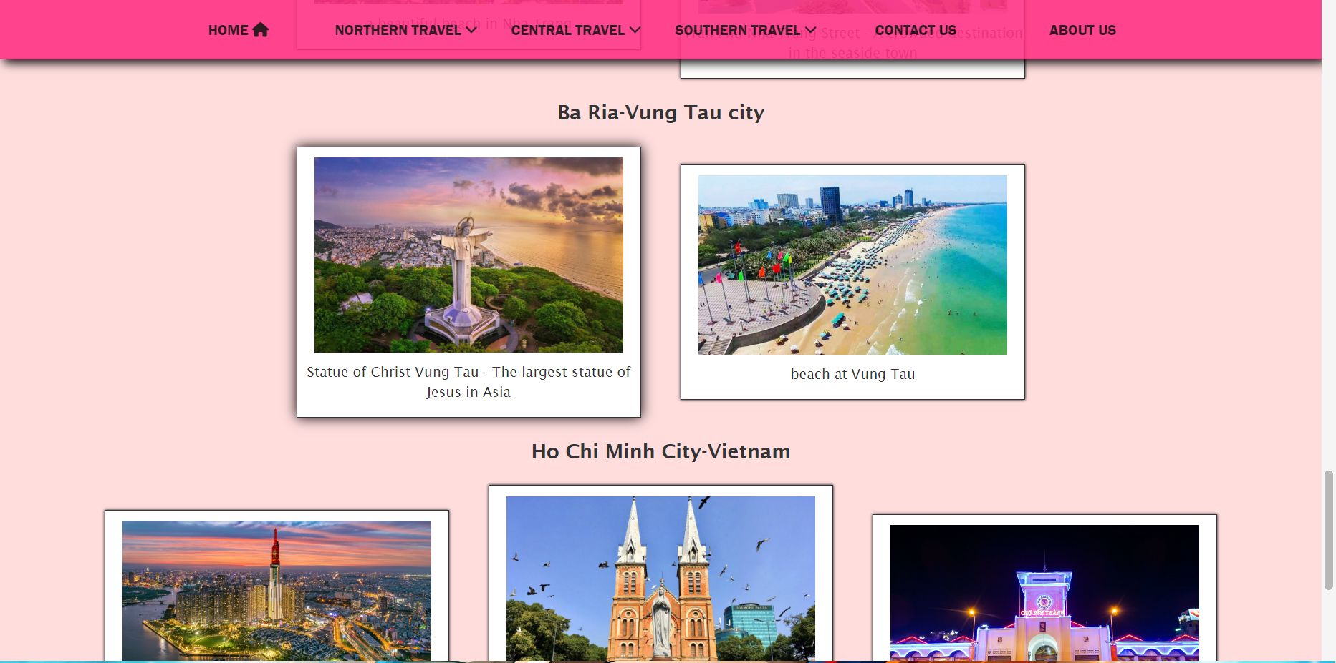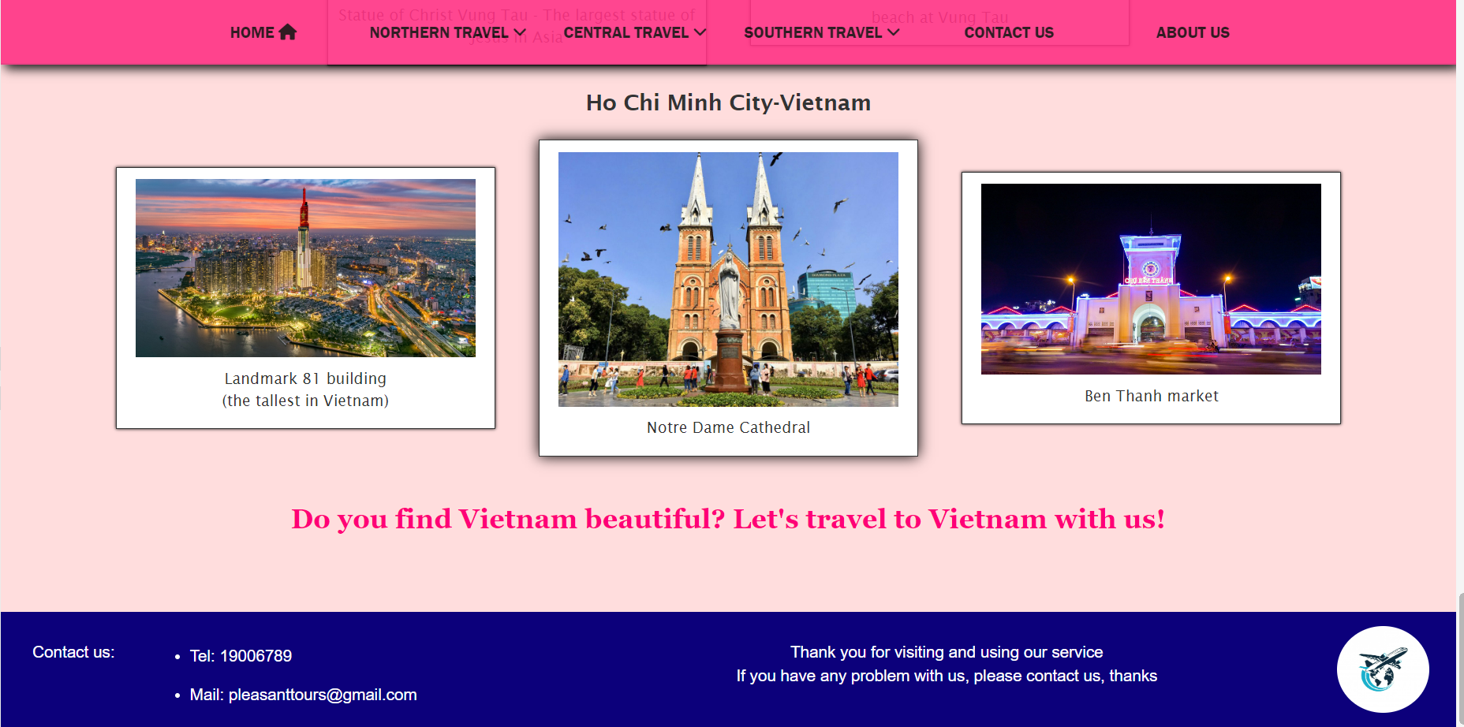**Overview of Homepage**

**Description Homepage:**

Homepage have:

+Header with logo, company name, hotline and company email

+Navigation bar with home, northern travel, central travel, southern travel, contact us and about us

+ Introduction image of travel theme and new year's sale banner 2023

+ introduce some famous tourist destinations in Vietnam.

+ Footer includes company hotline and email, thank you to customers and logo.

**2. product page**

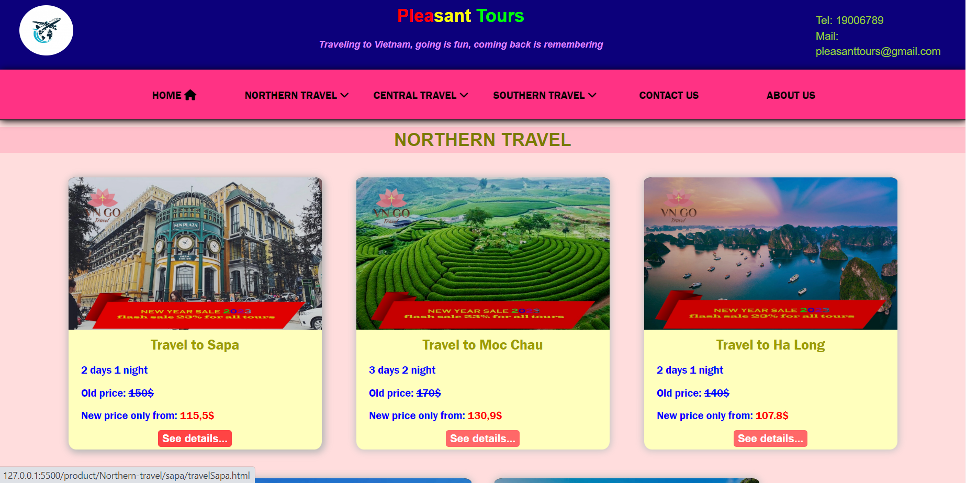

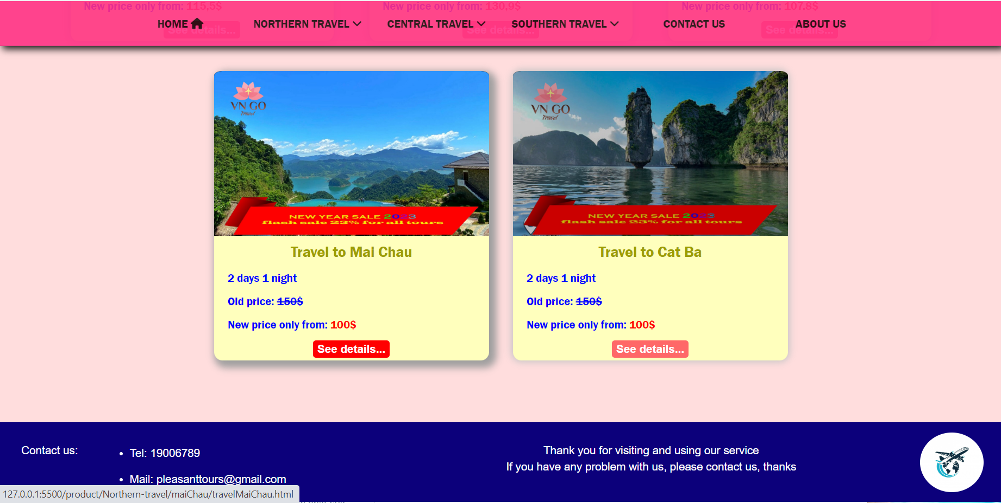

**product page overview:**

* also has header and footer like home page.
* In the middle of the page are product cards that simply describe the travels.

**3.detailed product page**

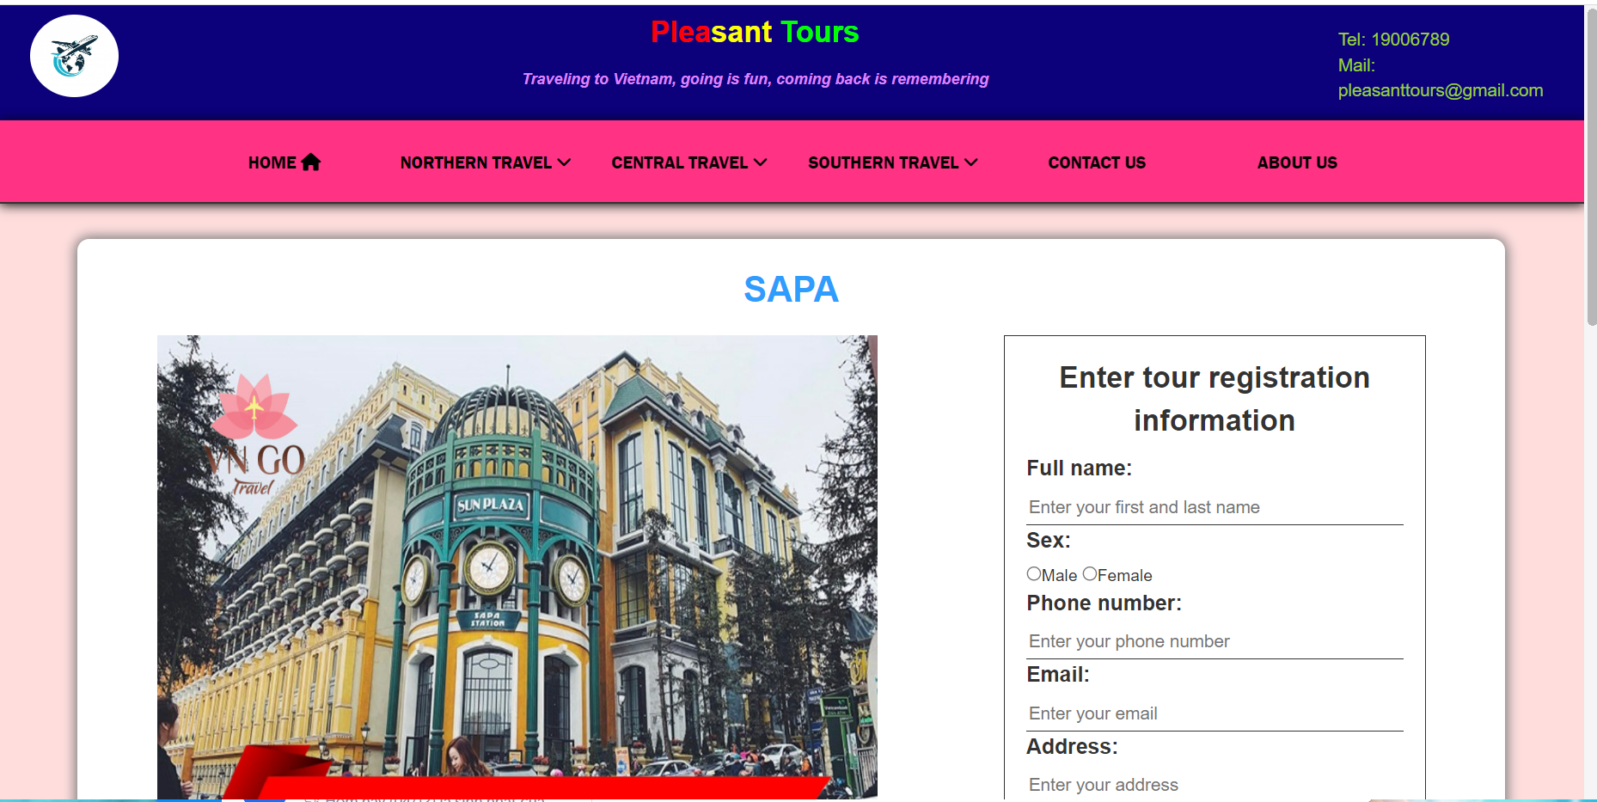

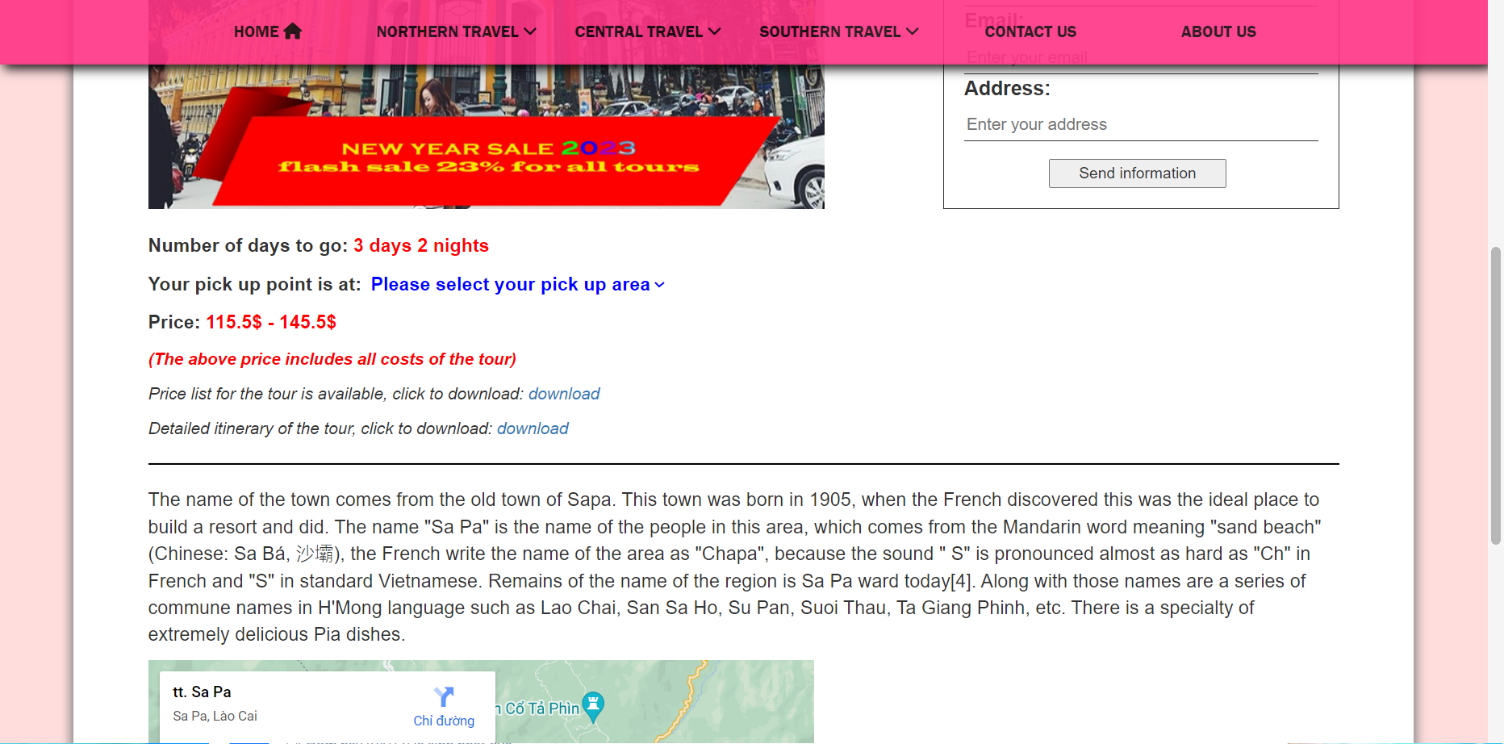

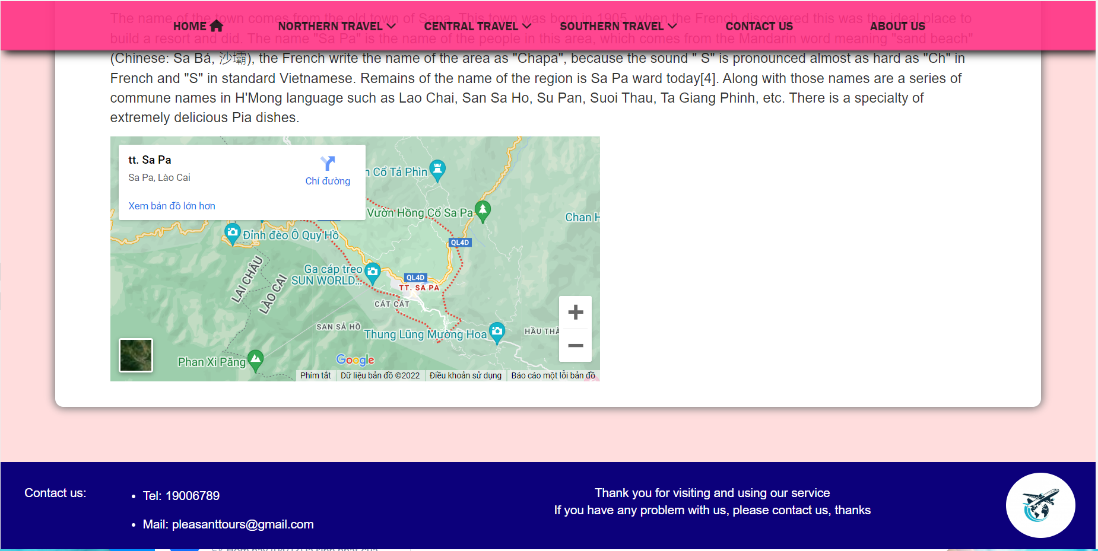

**detailed product page overview**

* include header, navbar and footer like home page.
* The content of the page shows more details about the tourist destination, the price, the image, the input bar for customers who want to register for the trip, the download link when the customer wants to see the trip details and the price. Finally, the location of the tourist destination is shown through google maps.

**4. about us page**

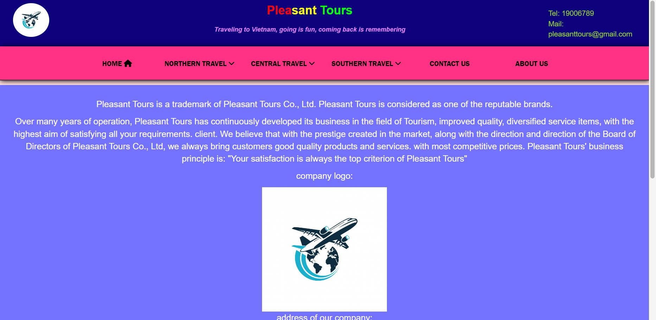

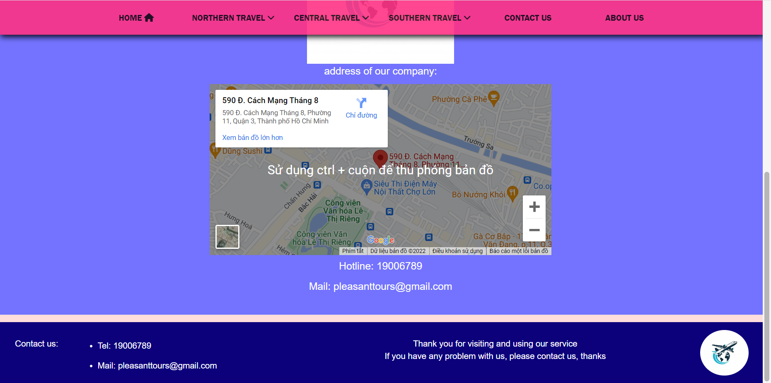

**about us page overview:**

* include header, navbar and footer like home page.
* The content is an introduction about our company, operating criteria, company logo, company's address shown via google maps and finally hotline number and email.